

**Microsoft Fabric**



Chat with your Data in a Day

Tenant Settings Guidance

Version:

September 2025

Contents

Document Structure 2

Introduction 3

AI Preparation 3

Task 1: Access the settings of the prepped semantic model 3

Fabric Tenant Settings for Standalone Copilot 4

Task 2: Check settings in the Admin Portal 5

References 13

# Document Structure

The lab includes steps for the user to follow along with associated screenshots that provide visual aid. In each screenshot, sections are highlighted with orange boxes to indicate the area(s) user should focus on.

# Introduction

As organizations embrace the power of Microsoft Fabric and Copilot to streamline analytics and unlock AI-driven insights, configuring the right **semantic model** and **tenant settings** becomes essential. This document provides a practical guide to the foundational settings that enable Standalone Copilot functionality and Fabric Data Agents to operate securely, efficiently, and in alignment with your governance standards.

In this supporting document you will learn about the following settings:

1. How to mark semantic models as Prepped for AI
2. Users can use Copilot and other features powered by Azure OpenAI.
3. Users can access a standalone, cross-item Power BI Copilot experience (preview)
4. Data sent to Azure OpenAI can be processed outside your capacity’s geographic region, compliance boundary, or national cloud instance
5. Only show AI-prepped items in the standalone Copilot in Power BI experience (preview)
6. Users can create and share Data agent item types (preview)
7. Allow XMLA endpoints and Analyze in Excel with on-premises semantic models

# AI Preparation

In this section, you will explore the AI settings in a semantic model in a Fabric-enabled workspace. We will focus on navigating the settings rather than creating any items.

**ℹ️ Important**

In the workshop, you experienced a **friction response** when using Copilot to return data from unprepped semantic models. By marking your semantic model as **Prepped for AI**, you enhance the standalone Copilot experience for end users and no longer get a friction response when receiving data from this semantic model. Models not marked as **prepped** will continue to result in warnings that the answer quality could be low.

## Task 1: Access the settings of the prepped semantic model

1. Log into Fabric and navigate to the Workspace named **Fabrikam_Lab_Initials**.
2. Click on the **ellipsis (…)** next to the semantic model.

1. Click on **Settings** from the menu.

1. Navigate to the AI preparation dropdown, check the box next to **Prepped for AI**, then select **Apply**.

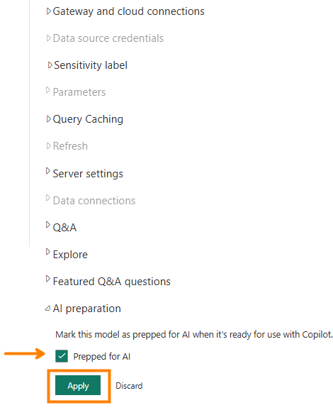

# Fabric Tenant Settings for Standalone Copilot

**ℹ️ Important**

The remaining tasks in this document, users will require Fabric Administrator privileges. Therefore, you will not be able to complete these steps or explore these tenant settings within the workshop environment. Complete this section by reading through the steps and familiarizing yourself with the process.

## Task 2: Check settings in the Admin Portal

1. In your Fabric workspace, click on the gear icon in the top right of the screen to view the **Settings** menu, then select **Admin portal.**

1. Find the search box (Filter by keyword) near the top right on your screen and type in **Copilot**.

1. Find and expand the section titled **Users can use Copilot and other features powered by Azure OpenAI.**

**ℹ️ Important**

This is marked Enabled by default. No changes are necessary.

1. Find and expand the section titled **Users can access a standalone, cross-item Power BI Copilot experience (preview).** Find and check (if it is not already) the **Enabled** box and choose whether you want this to apply to the entire organization, specific groups, or everyone *except* specific groups. Click **Apply** to save any changes.

**ℹ️ Important**

Copilot in Microsoft Fabric is available as a full-screen, standalone Copilot experience that finds and answers questions about any report, semantic model, or Fabric data agent within your tenant.

This experience is different from the Copilot pane within Power BI Desktop, which only answers questions about the report you currently have open.

1. Find and expand the section titled **Data sent to Azure OpenAI can be processed outside your capacity’s geographic region, compliance boundary, or national cloud instance.** This only applies if your geographic region is outside the EU Data Boundary or the United States.

1. Find and expand the section titled **Capacities can be designated as Fabric capacities.**

**ℹ️ Important**

This is **Disabled** by default but allows Fabric administrators to manage Fabric Copilot capacities for security and billing purposes. Changes made here take approximately 15 minutes to take effect.

1. Find and expand the section titled **Data sent to Azure OpenAI can be stored outside your capacity’s geographic region, compliance boundary, or national cloud instance.** This is similar to the section detailed in Step 5 above but applies to storage rather than processing.

1. Find and expand the section titled **Only show AI-prepped items in the standalone Copilot in Power BI experience (preview).**
2. Marking this section as enabled will guarantee that the standalone Copilot experience will only evaluate and return results from semantic models that are prepped for AI.

**ℹ️ Important**

Ensure the settings outlined in Step 3 above are **Enabled**. Then, click **Enabled** and **Apply** to allows users the best possible standalone Copilot experience by only showing items designated as **prepped for AI.**

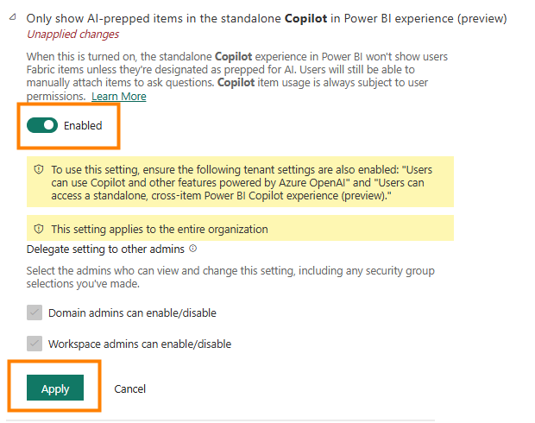

1. Filter the search bar to Data Agent



1. Find **Users can create and share Data agent item types (preview)** and click **enable.**
2. By default, this property is disabled at the tenant level. This property must be enabled in order to work with data agents!

1. Filter the search bar to XMLA Endpoint



1. Find **Allow XMLA endpoints and Analyze in Excel with on-premises semantic models** and click **enable**.

1. Data Agents can query and manage Power BI Semantic models via XMLA endpoints, enabling this feature makes that possible.

# References

Chat With Your Data in a Day (CWYDIAD) introduces you to some of the key features when using standalone Copilot in a Fabric workspace.

In the menu of the service, the Help (?) section has links to some great resources. Keep in mind the view that you see is dependent upon what experience you are currently in and therefore your options may look different than the screenshot below.

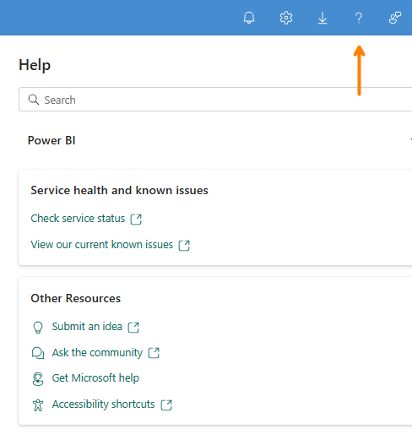

Here are a few more resources that will help you with your next steps with Microsoft Fabric.

* Access all the information in the main [Microsoft Fabric Documentation](https://learn.microsoft.com/en-us/fabric/)
* Explore Fabric through the [Guided Tour](https://aka.ms/Fabric-GuidedTour)
* Sign up for the [Microsoft Fabric free trial](https://aka.ms/try-fabric)
* Visit the [Microsoft Fabric website](https://aka.ms/microsoft-fabric)
* Learn new skills by exploring the [Fabric Learning modules](https://aka.ms/learn-fabric)
* Read the [free e-book on getting started with Fabric](https://aka.ms/fabric-get-started-ebook)
* Join the [Fabric community](https://aka.ms/fabric-community) to post your questions, share your feedback, and learn from others

Read the more in-depth Copilot-relevant technical documentation:

* [Copilot for Power BI Overview - Power BI | Microsoft Learn](https://learn.microsoft.com/en-us/power-bi/create-reports/copilot-introduction)
* [Standalone Copilot Experience in Power BI (Preview) – Power BI | Microsoft Learn](https://learn.microsoft.com/en-us/power-bi/create-reports/copilot-chat-with-data-standalone)
* [Microsoft Fabric Copilot admin settings | Microsoft Learn](https://learn.microsoft.com/en-us/fabric/admin/service-admin-portal-copilot)
* [Fabric data agent creation (preview) - Learn how to create a Fabric data agent | Microsoft Learn](https://learn.microsoft.com/en-us/fabric/data-science/concept-data-agent)
* [Best practices for configuring your data agent - Microsoft Fabric | Microsoft Learn](https://learn.microsoft.com/en-us/fabric/data-science/data-agent-configuration-best-practices)
* [Copilot for Microsoft Fabric and Power BI: FAQ - Microsoft Fabric | Microsoft Learn](https://learn.microsoft.com/en-us/fabric/fundamentals/copilot-faq-fabric)

© 2024 Microsoft Corporation. All rights reserved.

By using this demo/lab, you agree to the following terms:

The technology/functionality described in this demo/lab is provided by Microsoft Corporation for purposes of obtaining your feedback and to provide you with a learning experience. You may only use the demo/lab to evaluate such technology features and functionality and provide feedback to Microsoft. You may not use it for any other purpose. You may not modify, copy, distribute, transmit, display, perform, reproduce, publish, license, create derivative works from, transfer, or sell this demo/lab or any portion thereof.

COPYING OR REPRODUCTION OF THE DEMO/LAB (OR ANY PORTION OF IT) TO ANY OTHER SERVER OR LOCATION FOR FURTHER REPRODUCTION OR REDISTRIBUTION IS EXPRESSLY PROHIBITED.

THIS DEMO/LAB PROVIDES CERTAIN SOFTWARE TECHNOLOGY/PRODUCT FEATURES AND

FUNCTIONALITY, INCLUDING POTENTIAL NEW FEATURES AND CONCEPTS, IN A SIMULATED

ENVIRONMENT WITHOUT COMPLEX SET-UP OR INSTALLATION FOR THE PURPOSE DESCRIBED

ABOVE. THE TECHNOLOGY/CONCEPTS REPRESENTED IN THIS DEMO/LAB MAY NOT REPRESENT FULL

FEATURE FUNCTIONALITY AND MAY NOT WORK THE WAY A FINAL VERSION MAY WORK. WE ALSO

MAY NOT RELEASE A FINAL VERSION OF SUCH FEATURES OR CONCEPTS. YOUR EXPERIENCE WITH USING SUCH FEATURES AND FUNCITONALITY IN A PHYSICAL ENVIRONMENT MAY ALSO BE DIFFERENT.

**FEEDBACK**. If you give feedback about the technology features, functionality and/or concepts described in this demo/lab to Microsoft, you give to Microsoft, without charge, the right to use, share and commercialize your feedback in any way and for any purpose. You also give to third parties, without charge, any patent rights needed for their products, technologies and services to use or interface with any specific parts of a Microsoft software or service that includes the feedback. You will not give feedback that is subject to a license that requires Microsoft to license its software or documentation to third parties because we include your feedback in them. These rights survive this agreement.

MICROSOFT CORPORATION HEREBY DISCLAIMS ALL WARRANTIES AND CONDITIONS WITH REGARD

TO THE DEMO/LAB, INCLUDING ALL WARRANTIES AND CONDITIONS OF MERCHANTABILITY,

WHETHER EXPRESS, IMPLIED OR STATUTORY, FITNESS FOR A PARTICULAR PURPOSE, TITLE AND NON-

INFRINGEMENT. MICROSOFT DOES NOT MAKE ANY ASSURANCES OR REPRESENTATIONS WITH REGARD TO THE ACCURACY OF THE RESULTS, OUTPUT THAT DERIVES FROM USE OF DEMO/ LAB, OR SUITABILITY OF THE INFORMATION CONTAINED IN THE DEMO/LAB FOR ANY PURPOSE.

**DISCLAIMER**

This demo/lab contains only a portion of new features and enhancements in Microsoft Power BI. Some of the features might change in future releases of the product. In this demo/lab, you will learn about some, but not all, new features.